Code Description

There are three parts of the code：Java、Matlab and Database。

# Java

Mainly including some preprocessor:

* separateXmlFiles is used to break up large xml file, so easy to follow-up processing。
* UsingAccessDatabase is used to read the xml file, and then organize the data and write it to the Access database。
* WordCount is used to count the frequency of words appearing in the title。

# Matlab

Mainly include computing of semantic vector, and the code of GUI interface design. The “cleanData” in the Database should be configured to the ODBC database, because the need to use ODBC way to call the database.

* getAuthorVector.m：Calculate the author's semantic vector
* getWordsVector.m：Calculate the semantic vector of words
* getIndex.m：Get the index
* normalization.m：Normalized Semantic Vector
* SearchForAuthor.m：Find keywords and authors of an author's related field
* AuthorSearch.m：GUI interface

# Database

It is the main part of the program, which is mainly on the database integration and code query. SQL language is used to query code.

* Authors table：All of the authors and their articles

code：

SELECT Article_Author.[Author] AS Author, COUNT(*) AS NumOfArticles

FROM Article_Author

GROUP BY Author

ORDER BY COUNT(*) DESC;

result：Total 130516 records

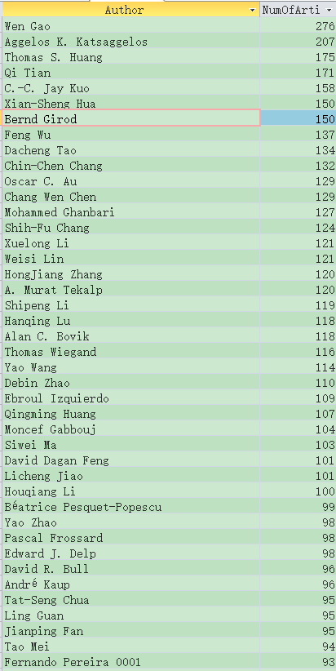

* Authors_Frequent_1（sup>2）table：The number of authors and their articles with a support count greater than 2 (a frequent set)

code：

SELECT Article_Author.[Author] AS Author, COUNT(*) AS NumOfArticles

FROM Article_Author

GROUP BY Author

HAVING (((Count(*))>2))

ORDER BY COUNT(*) DESC;

Result ：Total 25662 records

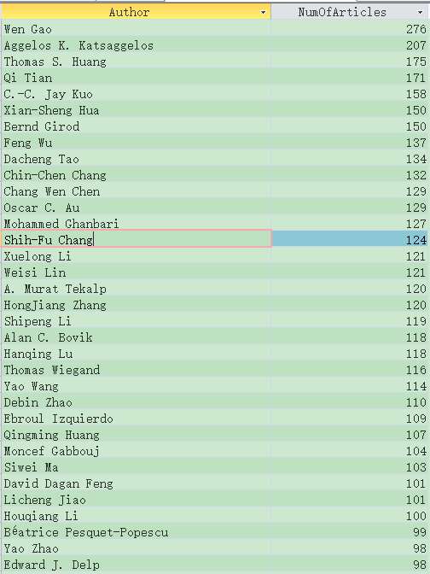

* Article_Author_Frequent_1 table：connection between Authors_Frequent_1（sup>2）table and Article_Author table

code：

SELECT Article_Author.title AS title, Article_Author.Author AS Author

FROM Article_Author, [Authors_Frequent_1（sup>2）]

WHERE Article_Author.Author = [Authors_Frequent_1（sup>2）].Author

ORDER BY title DESC;

result：Total 182351 records

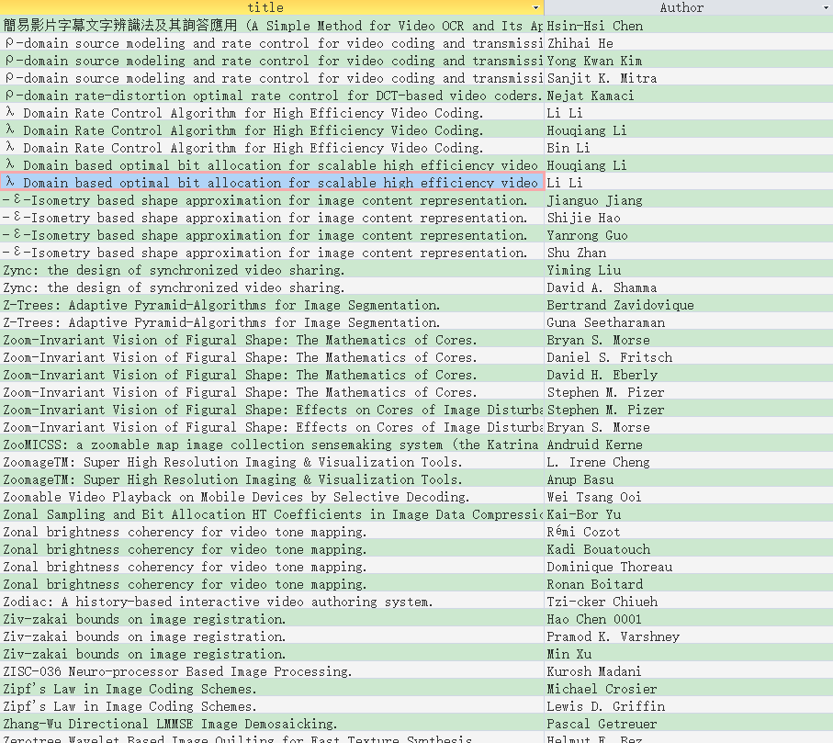

* Authors_Frequent_2（sup>2）table：The number of the author 1、the author 2 and there cooperation articles with a support count greater than 2 (two frequent sets)

code：

SELECT Article_Author_Frequent_1.[Author] AS Author1, Article_Author_Frequent_1_copy.[Author] AS Author2, COUNT(*) AS NumOfCoArticles

FROM Article_Author_Frequent_1,Article_Author_Frequent_1 AS Article_Author_Frequent_1_copy

WHERE Article_Author_Frequent_1.title=Article_Author_Frequent_1_copy.title AND Article_Author_Frequent_1.[Author]>Article_Author_Frequent_1_copy.[Author]

GROUP BY Article_Author_Frequent_1.[Author], Article_Author_Frequent_1_copy.[Author]

HAVING (((Count(*))>2))

ORDER BY COUNT(*) DESC;

result：Total 24633 records

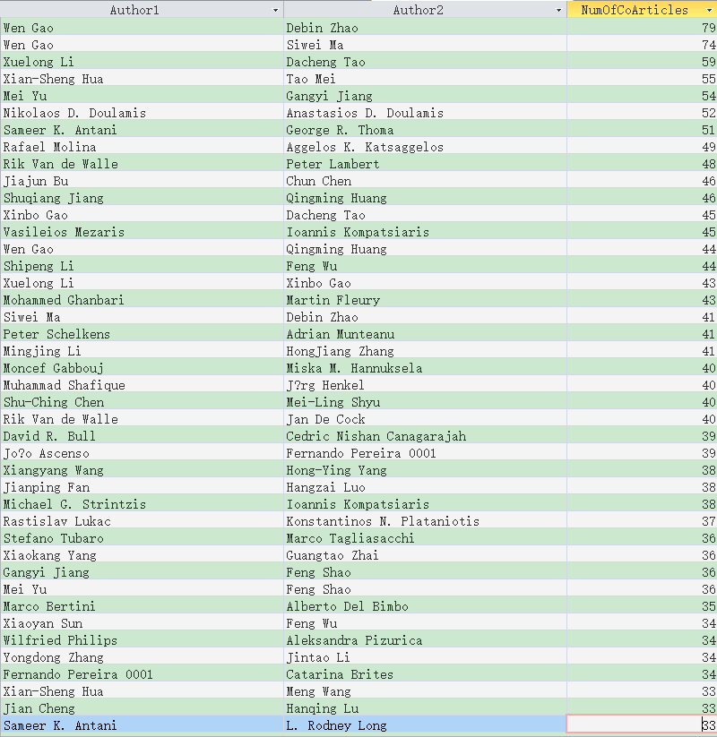

* Evaluate the relationship between the two frequent sets with the six pattern assessment methods, and evaluate which relationship is better

Put the statistical results into the excel table, and calculate the various models of assessment methods according to the formula

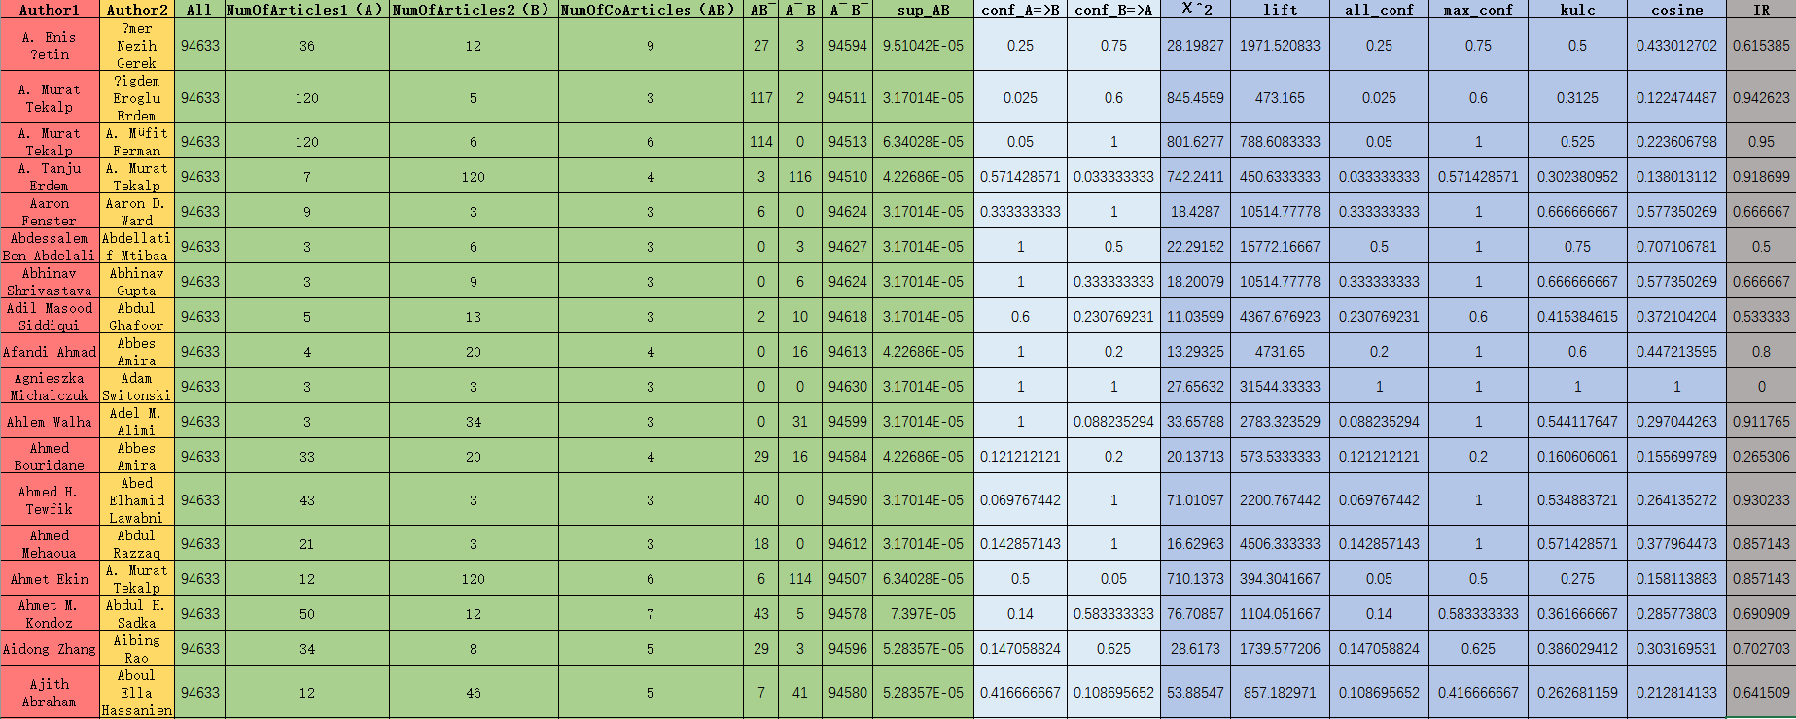

* Assessment of teacher-student relationship

Need to find each author first article published time FirstPubYear

* Author table：

code：

SELECT Article_Author.[Author] AS Author, COUNT(*) AS NumOfArticles, MIN(Articles.year_) AS FirstPubYear

INTO Authors

FROM Article_Author, Articles

WHERE Articles.title=Article_Author.title

GROUP BY Author

ORDER BY COUNT(*) DESC;

result：total 130516 records

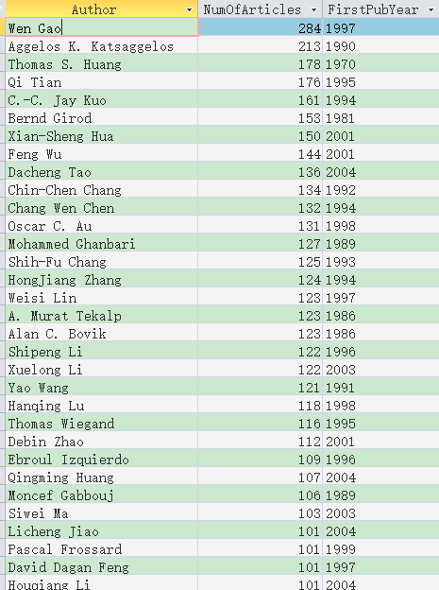

Need to find the number of coauthor of per author

* NumOfCoAuthors table：

code：

SELECT DISTINCT Article_Author.Author AS Author, Article_Author_copy.Author AS CoAuthor

FROM Article_Author, Article_Author AS Article_Author_copy

WHERE Article_Author.title = Article_Author_copy.title AND Article_Author.Author<>Article_Author_copy.Author;结果：

SELECT [查询NumOfCoAuthors].Author AS Author, COUNT(*) AS NumOfCoAuthors

INTO NumOfCoAuthors

FROM [查询NumOfCoAuthors]

GROUP BY [查询NumOfCoAuthors].Author

result：total 127758 records

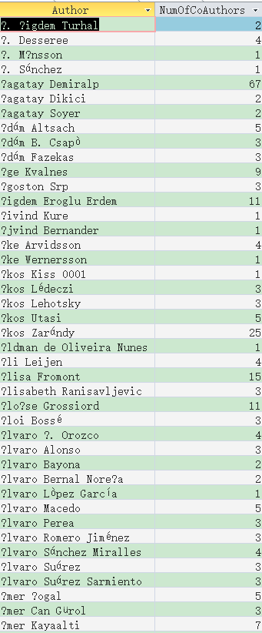

And then integrate all the information into a Complex table, including the Frequent_Patterns table, the FirstPubYear table and the NumOfCoAuthors table

* Complex table：

code：

SELECT Frequent_Patterns.Author1 AS Author1, Frequent_Patterns.Author2 AS Author2, Frequent_Patterns.[All] AS [All], Frequent_Patterns.[NumOfArticles1（A）] AS NumOfArticles1（A）, Frequent_Patterns.[NumOfArticles2（B）] AS NumOfArticles2（B）, Frequent_Patterns.[NumOfCoArticles（AB）] AS NumOfCoArticles（AB）, Frequent_Patterns.[AB ̅] AS [AB ̅], Frequent_Patterns.[A ̅ B] AS [A ̅ B], Frequent_Patterns.[A ̅ B ̅] AS [A ̅ B ̅], Frequent_Patterns.lift AS lift, Frequent_Patterns.all_conf AS all_conf, Frequent_Patterns.max_conf AS max_conf, Frequent_Patterns.kulc AS kulc, Frequent_Patterns.cosine AS cosine, Frequent_Patterns.[χ^2] AS [χ^2], Frequent_Patterns.IR AS IR, NumOfCoAuthors1.NumOfCoAuthors AS NumOfCoAuthors1, NumOfCoAuthors2.NumOfCoAuthors AS NumOfCoAuthors2, FirstPubYear1.FirstPubYear AS FirstPubYear1, FirstPubYear2.FirstPubYear AS FirstPubYear2 INTO Complex

FROM Frequent_Patterns, NumOfCoAuthors AS NumOfCoAuthors1, NumOfCoAuthors AS NumOfCoAuthors2, FirstPubYear AS FirstPubYear1, FirstPubYear AS FirstPubYear2

WHERE Frequent_Patterns.Author1=NumOfCoAuthors1.Author AND Frequent_Patterns.Author2=NumOfCoAuthors2.Author AND Frequent_Patterns.Author1=FirstPubYear1.Author AND Frequent_Patterns.Author2=FirstPubYear2.Author;

result：total 24633 records

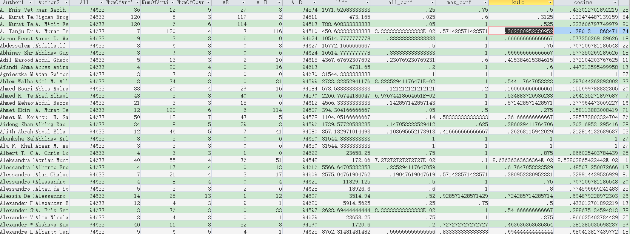

Lastly, get the more likely teacher-student relationship table by filtering the Complex table

* Complex_Filtered table：

code：

SELECT Frequent_Patterns.Author1 AS Author1, Frequent_Patterns.Author2 AS SELECT *

INTO Complex_Filtered

FROM Complex

WHERE max_conf>0.5 AND (max_conf-all_conf)/all_conf>0.5 AND IR>0.5 AND ABS(FirstPubYear1-FirstPubYear2)>5 AND ABS(NumOfCoAuthors1-NumOfCoAuthors2)>2

result：total 5951 records

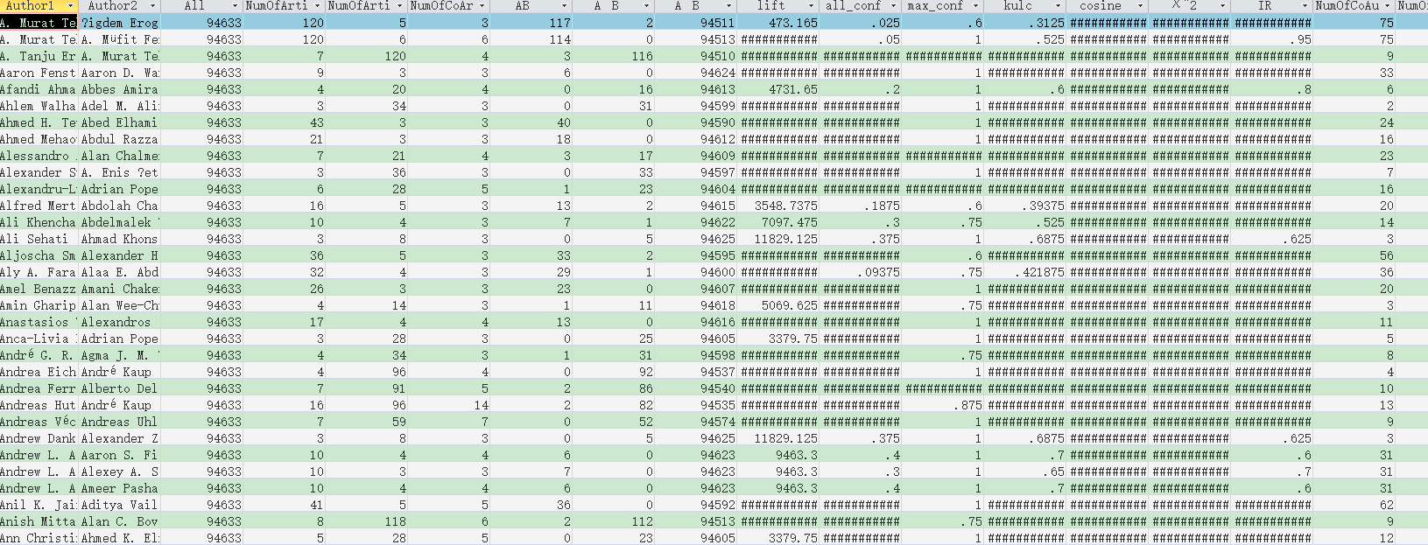

Get the Advisor_Advisee table by connecting Complex_Filtered table 、Article_Author table、Articles table

* Advisor_Advisee table：

code：

SELECT IIf(Complex_Filtered.FirstPubYear1<Complex_Filtered.FirstPubYear2, Complex_Filtered.Author1, Complex_Filtered.Author2) AS Advisor, IIf(Complex_Filtered.FirstPubYear1<Complex_Filtered.FirstPubYear2, Complex_Filtered.Author2, Complex_Filtered.Author1) AS Advisee

FROM Complex_Filtered

SELECT [查询Advisor_Advisee].Advisor AS Advisor, [查询Advisor_Advisee].Advisee AS Advisee,MIN(Articles.year_) AS FirstCoPubYear, MAX(Articles.year_) AS LastCoPubYear

INTO Advisor_Advisee

FROM [查询Advisor_Advisee], Article_Author AS Article_Author1, Article_Author AS Article_Author2, Articles

WHERE [查询Advisor_Advisee].Advisor=Article_Author1.Author AND [查询Advisor_Advisee].Advisee=Article_Author2.Author AND Article_Author1.title=Article_Author2.title AND Articles.title=Article_Author1.title

GROUP BY Advisor,Advisee

ORDER BY Advisor

result：total 5951 records

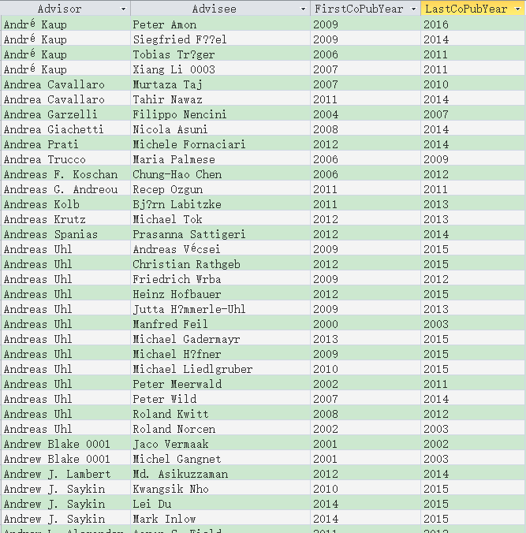

* Advanced Semantic Annotations

Firstil, extract the title of all the articles from the Article_Author table

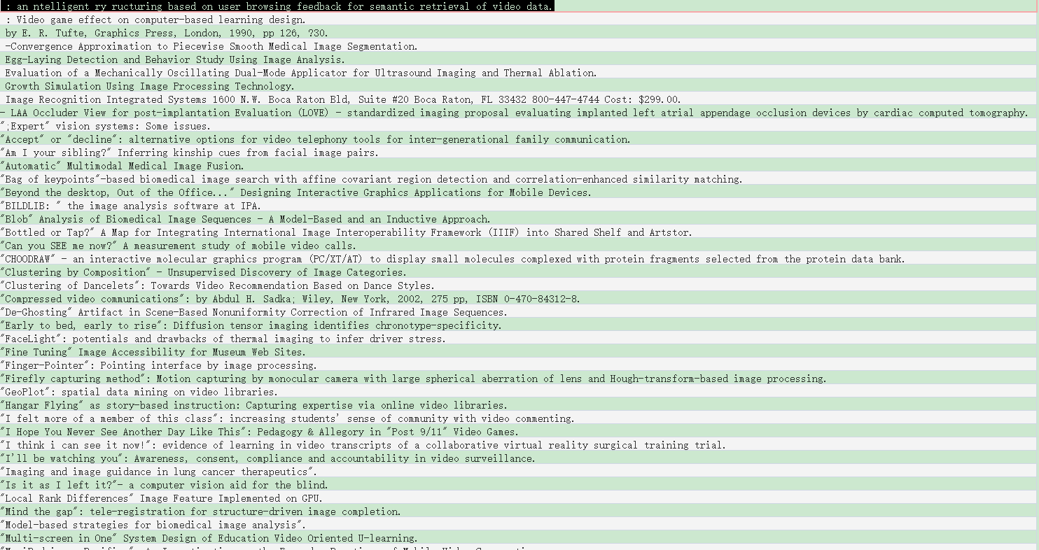

Then, get the frequent occurrence of meaningful academic keywords and their count by analysis the text information and sieve to "and", "on", "for" adverbs.

Result: total 5061 records.

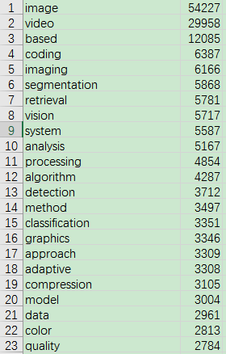

The top 100 keywords are extracted as a vector base.

Calculate the semantic feature vector of each word and each author. And these 100 feature keywords appear simultaneously in an article, frequency and frequent patterns